SECTION1 | SQL

Single column index

Created based on only one table column

Composite index

Indexes with multiple columns within them that provide faster query times.

Clustered index

an index which defines the physical order in which table records are stored in a database.

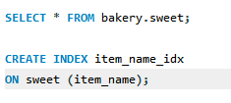

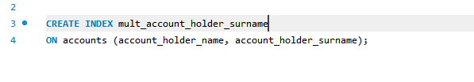

SECTION 2 | PYTHON

1. The number 8 is a string rather than an integer so it is printing 8 4 times rather than doing 8 multiplied by 4. It should read:

egg_boxes = 4

eggs_per_box = 8

total_eggs = egg_boxes * eggs_per_box

message = 'I have {} eggs'.format(total_eggs) print(message)

1. Calling the function before defining it. Move to after:

def hello_world():

print("hello world")

hello_world()

1. Amount is being returned but not printed. This works:

def calculate_vat(amount):

print ( amount * 1.2 )

calculate_vat(100)

1. It prints the string ‘50’, 50 times increasing the number of times its printed by one e.g 50 then 5050 each time up to 50 times.
2. String slicing

**# Task 1 - Slice the word so that you get "work".**

**wrd="Homework"**

**# Type your answer here.**

**ans_1= wrd[4:]**

**print(ans_1)**

**# Task 2 - Slice the word until "w". (Home)**

**wrd="Homework"**

**# Type your answer here.**

**ans_1= wrd[:4]**

**print(ans_1)**

**# Task 3 - Now try to get "me" only.**

**wrd="Homework"**

**# Type your answer here.**

**ans_1= wrd[2:4]**

**print(ans_1)**

**# Task 4 - Now slice the word with steps of 2, excluding first and last characters wrd="Homework"**

**# Type your answer here.**

**ans_1= wrd[1:7:2]**

**print(ans_1)**

1. String slicing

The string in uppercase

print(string.lower())

The string in lowercase

print(string.upper())

Whether the word starts with the same letter as the last letter

if (string[0]) == (string[-1]):

print("True")

else:

print("False")

The string with all instances of the first letter replaced with “[REDACTED]”

print("[ REDACTED ]" + string[1:])